# 28 June 2016

**Miling of Chromium coated SiN membrane.**

**12:00**

**Parameters :**

|  |  |
| --- | --- |
| Coating | 5 nm Cr |
| Thickness | 5 + 100 nm |
| Beam | 10µm – 1pA (6) |
| Area Dose | 20000 µC/cm² |
| Loop factor | 1 |
| Dot dose | 2.0088 pC |
| Dot dwell time | 2287.93 ms |
| Design | *Fp-triangle2* |
| Design Dose factor | *1* |

**Notes :**

On the design points are now on top of triangle  
Area step size 0.0032  
i=0.878pA

**Results :**

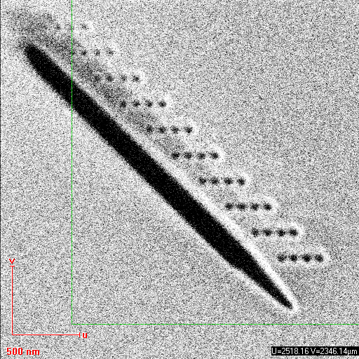

The triangle is not well-milled because there is only one loop. It pierces through the membrane anyway. But it is hard to tell if the dots pierced through it.

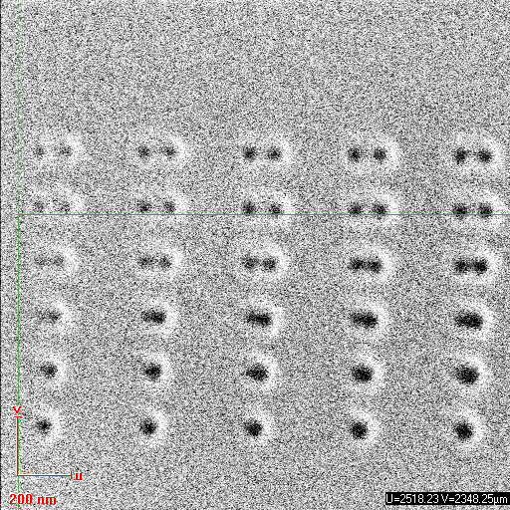

Point of dose factor 0.6 to 1.4, separated by (up to bottom) 100, 80,60,40,20 and 10 nm

We can distinguish points separated by ~50 nm. The minimal diameter of a point we achieve is **50nm**.

We now try the same experience with loops. We set the dot dose to 0.10044 to have the same total dose (2.0088 pC )

**13:00 – 14:00**

**Parameters :**

|  |  |
| --- | --- |
| Coating | 5 nm Cr |
| Thickness | 5 + 100 nm |
| Beam | 10µm – 1pA (6) |
| Measured current |  |
| Area Dose | 1000 µC/cm² |
| Area step size | 0.0032 |
| Area dwell time | 0.109989 ms |
| Loop factor | 20 |
| Dot dose | 0.10044 pC |
| Dot dwell time | 107.883995 ms |
| Design | *Fp-triangle2* |
| Design Dose factor | *1* |

**Results :**

We obtained a huge astigmatism… We try the same experiment with better settings.

**14:30 – 16:30**

**Parameters  :**

|  |  |
| --- | --- |
| Coating | 5 nm Cr |
| Thickness | 5 + 100 nm |
| Beam | 10µm – 1pA (6) |
| Measured current | **0.26 pA** |
| Area Dose | 1000 µC/cm² |
| Loop factor | 20 |
| Dot dose | 0.10044 pC |
| Design | *Fp-triangle2* |
| Design Dose factor | *1* |

**Results :**

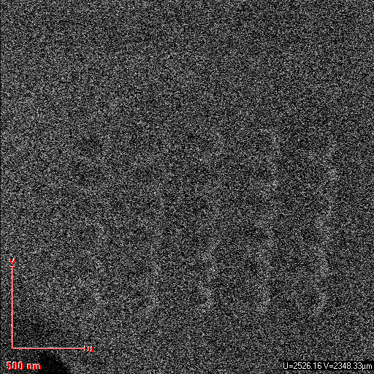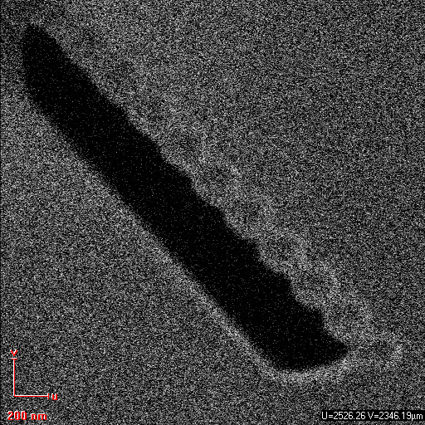We tried the same parameter as before after setting the aperture and stigmatism better.  
However we had very low current that’s why dots didn’t pierce the membrane.

Either the software does not provide 0.10044 pC each loop, even though we had a long dwell time to compensate the low current, or either the depth of the milling is not only linked to the dot dose, but also to the time of exposure.   
It seems that long-time milling at low current is not as effective as short milling at higher current.  
The triangle still pierces through the membrane.

**16:45 – test of lines and dots  
 We try to make fall a part of the membrane by milling around it, with dots or with lines.**

**Parameters  :**

|  |  |
| --- | --- |
| Coating | 5 nm Cr |
| Thickness | 5 + 100 nm |
| Beam | 10µm – 1pA (6) |
| Measured current | **0.771pA** |
| Line Dose | 20000 µC/cm² |
| Line dwell time |  |
| Loop factor | **1** |
| Dot dose | 2.0088 pC |
| Dot dwell time |  |
| Design | *Multiple-fall* |
| Design Dose factor | *1* |

**Results :**Two tests of Multiple falls for high (up) and low (bottom) line dose:

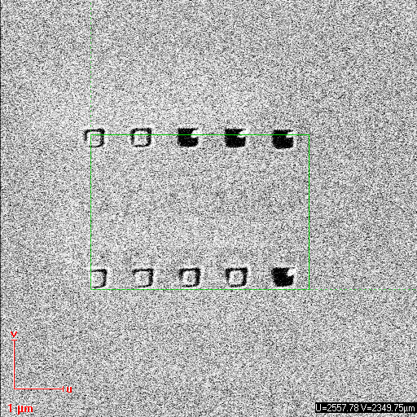

The design is composed of squares of lines and dots, of dose factor 1 to 1.8.  
The lines barely mill through the membrane, while the dots mill through it for a dose factor 1.8. That is 1.8*2.0088pC=**3.62pC** (but it looks like it also goes through it for lower dose)

The bottom left corner is badly milled, that may be due to bad charge extraction. It is also possible that the milling of other corners affects the Chromium coating around, and makes it easier to mile through it after. We should look at the milling live to know which part is milled last.

This is unfortunate, because this design would spare us much time in testing if we –or don’t- pierce through the membrane. As the previous one* we used requires a large area that takes up to 28minutes with 1pA:

* 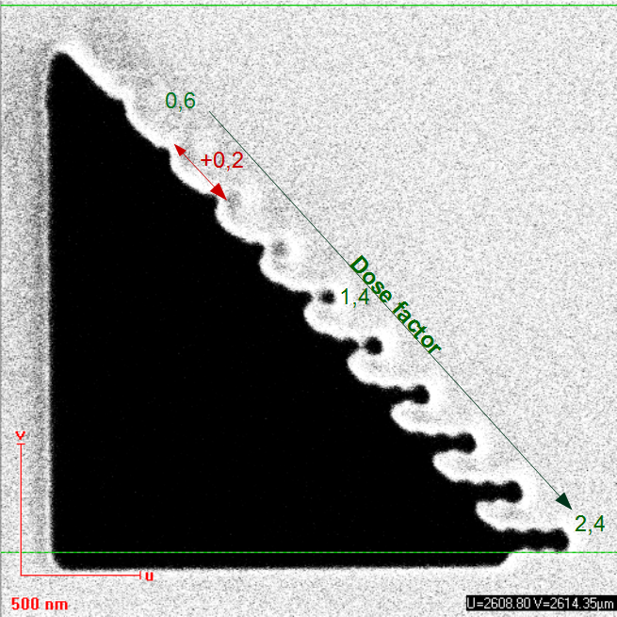

To know if we pierced through the membrane, there is another long method: we unload the sample and load it again, but upside down. Then we look for the place when we did our milling, and check if the hole was total.